**Stilting Components to a PCB**

**Jazmin Villegas**

**California Plug Load Research Center**

1. **What is stilting?**

Stilting is the process of attaching/soldering legs to a component in order to elevating the component by a desired height. This is a process to allow testing of a component where the packaging was not intended for mounting on the PCB that mounting will occur. Typically the PCB was intended for a smaller package component. Vertical height is used to compensate for lack of lateral space with component placement. In this case two opto-isolators are too close to be mounted properly. Both parts are stilted to permit mounting without interference.

1. **Why so you need to stilt?**

U5 U6

When applying components to a printed circuit board (PCB) you may find that there is a crowd of components in a certain area, resulting in component-component interference. This may not allow you to use the conventional methods of soldering or the soldering paste as you have intended. As shown in the picture on the right, components U6 and U5 had been placed in close proximity to one another, not allowing for either to be placed properly on the pads intended for connections to this component. With stilting we will be able to elevate one component (or both) allowing for proper connectivity of all components.

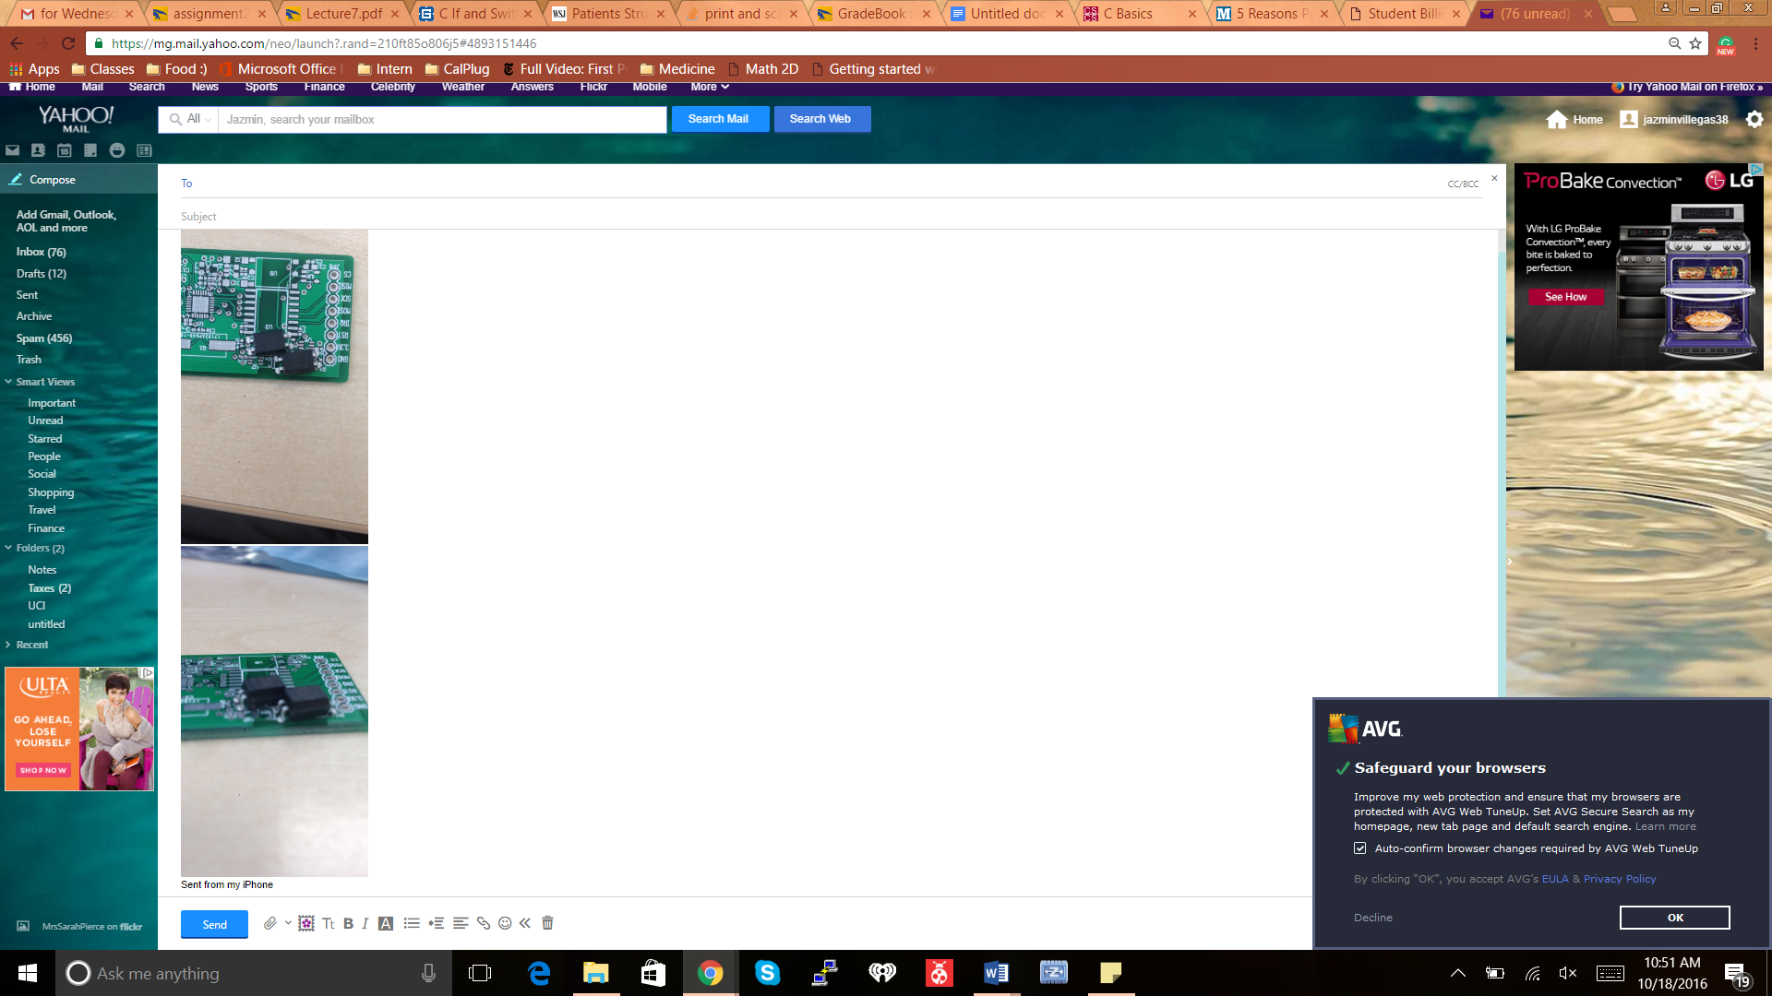

**Figure 1:** Neither U6 nor U5 are able to align with the pads on the PCB. Both components have four legs.

1. **How to Stilt.**

To beginning the process of stilting you will need to make sure your component is sanitized and fully functional.

* 1. First, we will begin by applying a metal stilt to each leg. Use the cut leads from a 1/4th watt resistor as the interconnect leads. Having malleable stilts allows you to freely adjust your component for the best allignment to pads while preventing interference on the board. These legs are generally tin-clad copper wire. When applying the metal, you would like to measure how much height is needed to allow best allignment. In our case, we only needed one component stilted with the height being more than its bordering components. Make sure all legs are cut to the proper height before soldering, a final trimming will occur after soldering each leg to the part to mount.
  2. After you have measured and trimmed all the stilts for your component, you can now solder each stilt to a corresponding leg. Use tweezers to hold part when soldering to prevent burs. Tin both the component and the wire before performing the joining via soldering. When you finish soldering check the height of the stilts once again, if the stilts have shifted in height cut the appropriate amount of metal from the stilts so the component can lay on a flat surface. The stilts should align with the pads and the component should sit flat on the stilts. Do not mount to some pads and warp the other legs to meet remaining pads. It is easy to tear pads off the PCB when doing this.
  3. Next you would like to position your component on your PCB ensuring that all stilts are placed on top of the corresponding solder pads. Soldering the stilt to the board will be a bit challenging. You will need to quickly apply solder each leg, the heat from the solder iron may loosen your any previous soldering you have completed. If this does happen reapply the loose piece(s) once again. Once you have completed applying all legs you would like to repeat this process for any other parts you would like stilted or continue soldering the rest of your other components.

Stilted Component

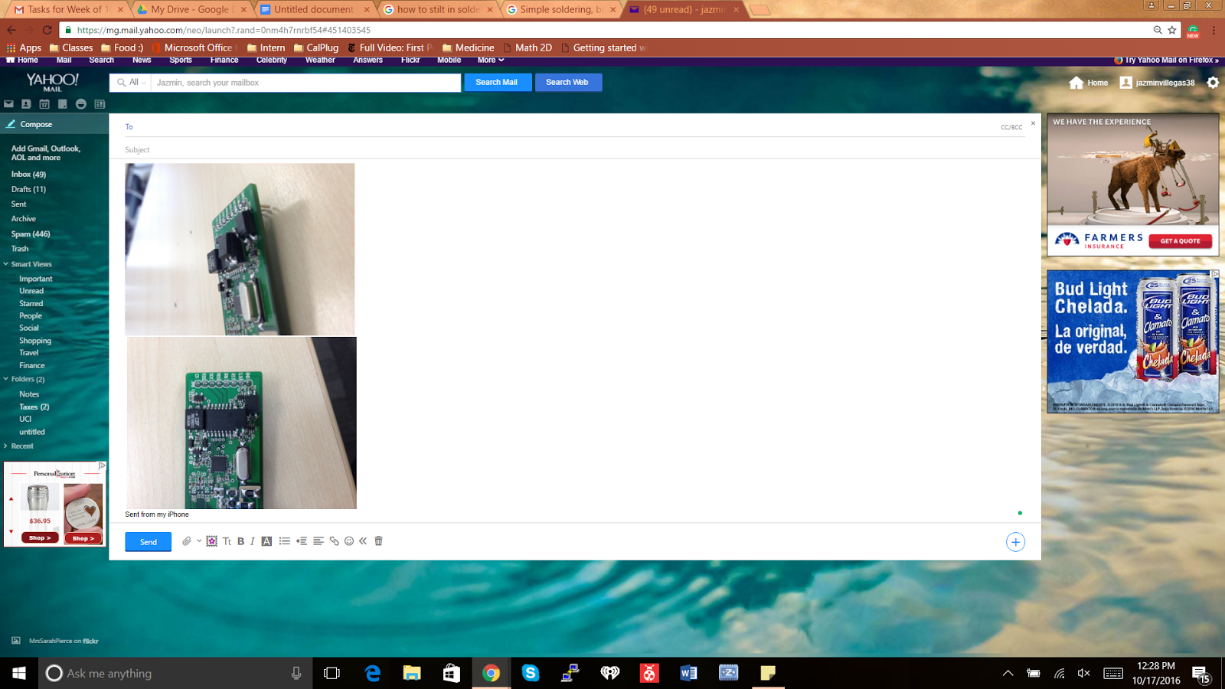

Figure 2: A finished PCB after stilting. The picture on the left is the top view. The picture on the right is the side view. Here you notice the component we have stilted. It is elevated above the components in its proximity allowing for the other components to lay flat on the PCB.